

620-56th Street East

Saskatoon, SK. S7K 8G5

Ph. (306) 664-8410

Fax (306) 664-8412

**SLIVEN CU630 LATHE**

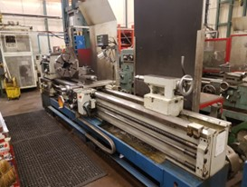

Good Condition 24x120 Lathe for Sale

Saskatoon, Saskatchewan

3mm center distance,

315mm center height,

630mm turning over bed,

430mm turning over cross slide,

103mm spindle bore,

12.5-1.250RPM

Call for Pricing